(Store/library/school name) is Proud to be a 105th Anniversary Children’s Book Week Event Host

Celebrate with us May 6th – May 12th!

FOR IMMEDIATE RELEASE

City, State — date —As part of the longest-running national celebration of books for young people and the joy of reading, over 2,300 schools, libraries, and bookstores from coast to coast in all 50 states will celebrate Children’s Book Week from May 6 to May 12.

This year marks the 105th anniversary of Children’s Book Week; the theme for this year’s celebration is No Rules. Just Read. The 2024 Children’s Book Week poster was created by Sophie Blackall. Sophie invites readers, young and old, to join the fun as the year’s official spokesperson.

We are proud to b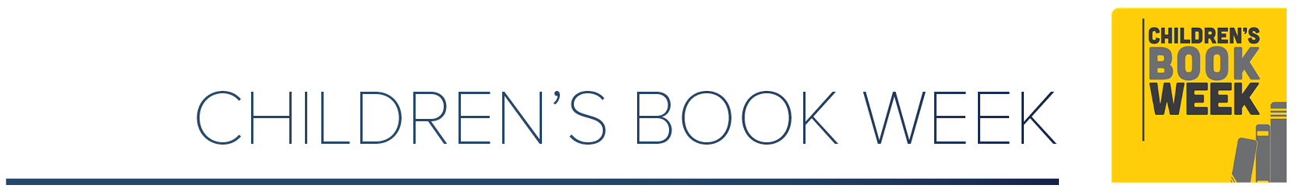e hosting the following event(s) in celebration of Children’s Book Week:

INSERT EVENT DETAILS

Date

Location

Time

Description

Everyone can access original bookmarks created by six acclaimed illustrators, activity pages by Sophie and other beloved book creators, and information about this year’s reading club, #ClubNoRulesJustRead.

Children’s Book Week is a cornerstone program of Every Child a Reader, a 501(c)(3) literacy charity dedicated to inspiring a lifelong love of reading in children and teens across America. Other national programs include  Get Caught Reading and the National Ambassador for Young People’s Literature—in partnership with the Library of Congress.

Contact:

Your name and title; contact information